Question 1:

https://loki.trentu.ca/~konradbartlett/3420/assignments/assn1/q1.html

<html lang="en">

<head>

<title>Student Timetable</title>

<link rel="stylesheet" href="css/q1.css">

</head>

<body>

<div>

<table border="1" width="900" cellpadding="1" cellspacing="0">

<tbody>

<tr>

<td colspan="6" style="font-size:23pt;"><div>0580964 - Konrad Bartlett - BSH.COIS - 2019 WINTER</div></td>

</tr>

<tr>

<th></th>

<th><div>Monday</div></th>

<th><div>Tuesday</div></th>

<th><div>Wednesday</div></th>

<th><div>Thursday</div></th>

<th><div>Friday</div></th>

</tr>

<tr>

<th>8:00</th>

<td></td>

<td rowspan=2><div>COIS-3420H-A-W01</div><div>LEC</div><div>08:00-09:50</div><div>PTBO SC-115</div></td>

<td rowspan=2><div>COIS-3020H-A-W01</div><div>LEC</div><div>08:00-09:50</div><div>PTBO CCN-M2</div></td>

<td></td>

<td></td>

</tr>

<tr>

<th>9:00</th>

<td></td>

<td></td>

<td></td>

</tr>

<tr>

<th>10:00</th>

<td></td>

<td><div>COIS-4470H-A-W01</div><div>LEC</div><div>10:00-10:50</div><div>PTBO GCS-112</div></td>

<td></td>

<td rowspan=2><div>COIS-4470H-A-W01</div><div>LEC</div><div>10:00-11:50</div><div>PTBO GCS-112</div></td>

<td></td>

</tr>

<tr>

<th>11:00</th>

<td></td>

<td></td>

<td></td>

<td></td>

</tr>

<tr>

<th>12:00</th>

<td><div>COIS-3420H-A-W01</div><div>LEC</div><div>12:00-12:50</div><div>PTBO SC-103</div></td>

<td></td>

<td></td>

<td></td>

<td></td>

</tr>

<tr>

<th>13:00</th>

<td></td>

<td><div>COIS-3050H-A-W01</div><div>LEC</div><div>13:00-13:50</div><div>PTBO GCS-108</div></td>

<td></td>

<td></td>

<td><div>COIS-3420H-A-W01</div><div>LAB</div><div>13:00-13:50</div><div>PTBO OCA-202</div></td>

</tr>

<tr>

<th>14:00</th>

<td rowspan=2><div>COIS-3020H-A-W01</div><div>LEC</div><div>14:00-15:50</div><div>PTBO CCN-M2</div></td>

<td></td><td ></td>

<td rowspan=2><div>COIS-3050H-A-W01</div><div>LEC</div><div>14:00-15:50</div><div>PTBO GCS-108</div></td>

<td></td>

</tr>

<tr>

<th>15:00</th>

<td></td><td ></td>

<td></td>

</tr>

<tr>

<th>16:00</th>

<td></td><td ></td>

<td></td>

<td></td>

<td></td>

</tr>

<tr>

<th>17:00</th>

<td></td>

<td></td>

<td></td>

<td></td>

<td></td>

</tr>

<tr>

<th>18:00</th>

<td rowspan=3><div>COIS-3560H-A-W01</div><div>LEC</div><div>18:00-20:50</div><div>PTBO OCA-208</div></td>

<td></td>

<td></td><td ></td>

<td></td>

</tr>

<tr>

<th>19:00</th>

<td></td>

<td></td>

<td></td>

<td></td>

</tr>

<tr>

<th>20:00</th>

<td></td><td ></td><td ></td><td ></td>

</tr>

<tr>

<th>21:00</th>

<td colspan="3"><div>DOTA</div><div>My house</div><div>21:00-00:00</div><div>PTBO DWTN</div></td>

<td></td>

<td></td>

</tr>

</tbody>

</table>

</div>

</body>

<footer></footer>

</html>

body{

background-color:black;

color: white;

font-family: "Comic Sans MS";

}

td{

width:100px;

height:80px;

font-size:10pt;

background-color:red;

font-weight:bold;

}

td:empty{

background-color: black;

}

th{

width:50px;

font-weight:bold;

}

p{

background-color:blue;

}

td div:first-of-type{

background-color:blue;

}

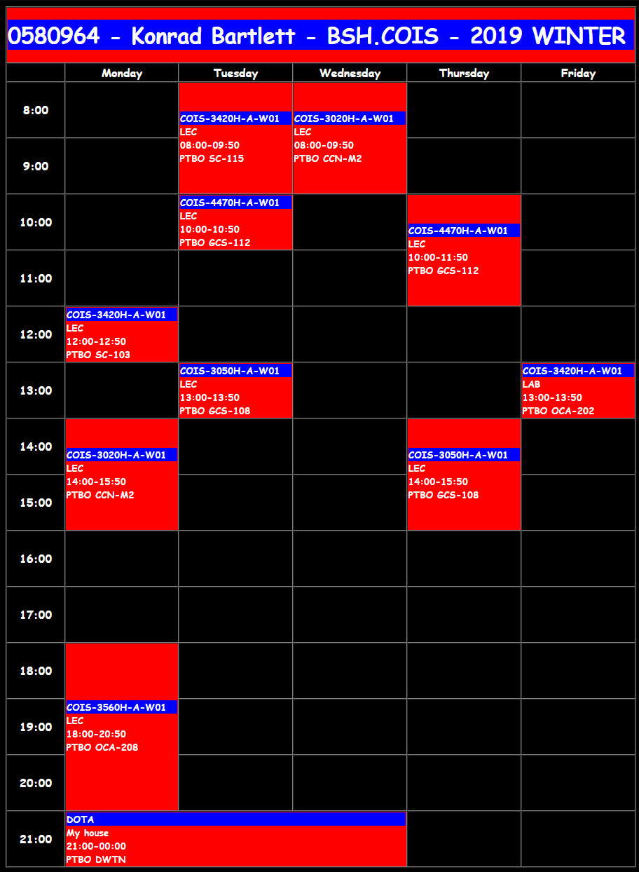

Question 2:

<https://loki.trentu.ca/~konradbartlett/3420/assignments/assn1/q2.html>

@import url('https://fonts.googleapis.com/css family=Titillium+Web:300,400,400i,600,600i,700');

h1, h2, h3{

font-family: 'Titillium Web', 'Arial', sans-serif;

}

#mainnav a{

color: purple;

}

#mainnav a:hover{

color: teal;

}

#mainnav ol {

list-style: lower-roman;

}

#mainnav ol a{

color: green;

}

#mainnav ol a:hover{

color: teal;

}

p::first-line{

font-weight: bold;

}

h2 + p::first-letter{

color: #903;

float: left;

font-family: Georgia;

font-size: 75px;

line-height: 60px;

padding-top:

4px; padding-right: 8px;

padding-left: 3px;

font-style:

normal;

}

body p a:hover{

color:olive;

}

table {

border: 1px solid grey;

}

tr:nth-child(even){

background-color: #e0f5ff;

}

tr > :first-child{

font-style: italic;

}

a[href^="http"]{

color: #508658;

}

a[href^="/"], a[href^=".."]{

color: #4d6c92;

}

a[href$=".pdf"]{

background: url("../img/pdf16.png") no-repeat right;

color: purple;

padding-right: 1.3em;

}

div ol#references{

column-count: 3;

column-gap: 50px;

}

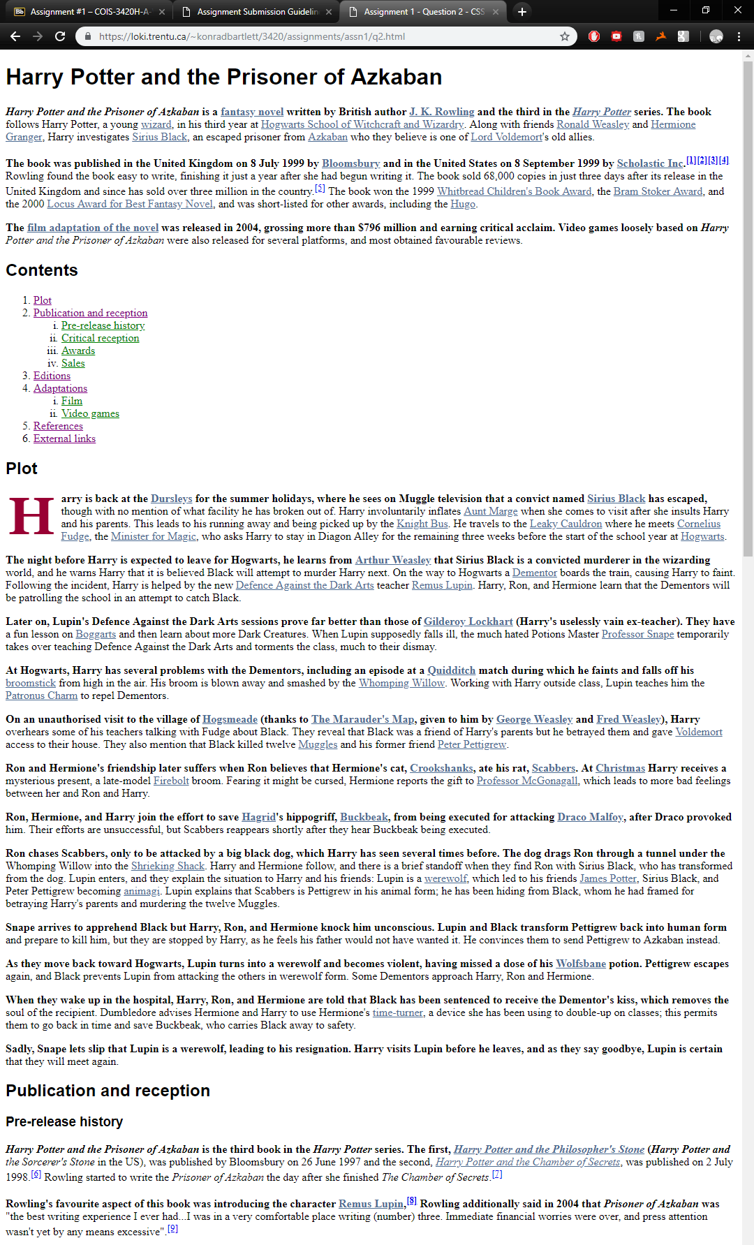

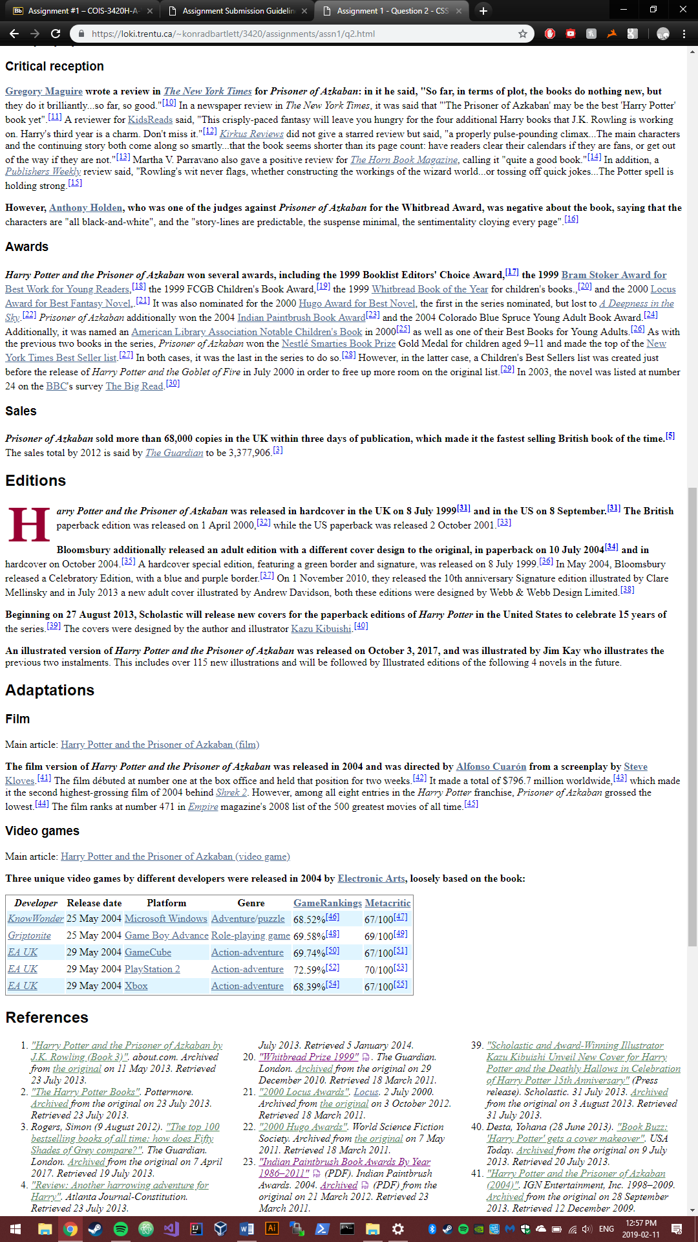

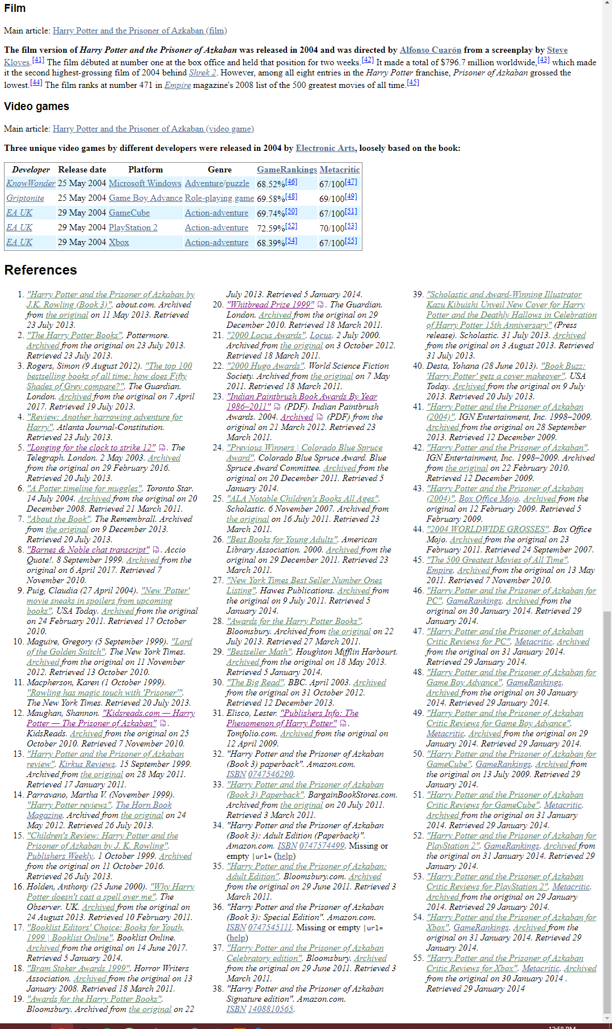Qq2

Question 3:

<https://loki.trentu.ca/~konradbartlett/3420/assignments/assn1/q3.html>

q3.css

#q3a.parent{

display: flex;

align-items: flex-end;

justify-content: space-between;

}

#q3b.parent{

display: flex;

flex-direction: column;

align-items: center;

}

#q3c.parent{

display: flex;

flex-wrap: wrap;

flex-direction: row-reverse;

justify-content: space-between;

}

#q3d.parent{

display: flex;

align-items: flex-end;

justify-content: center;

}

#q3d :nth-child(2){

align-self: flex-start;

}

#q3d :nth-child(3){

flex-grow: 1;

align-items: center;

}

#q3d :nth-child(4){

align-self: flex-start;

}

#q3d :nth-child(5){

align-self: flex-start;

}

#q3e.parent{

display: flex;

flex-direction: row;

color: yellow;

}

#q3e :nth-child(5){

order: 1;

align-self: flex-start;

}

#q3e :nth-child(3){

order: 2;

margin-right: auto;

align-self: flex-end

}

#q3e :nth-child(4){

order: 3;

align-self: flex-end;

}

#q3e :nth-child(6){

order: 4;

align-self: flex-end;

}

#q3e :nth-child(2){

order: 5;

align-self: flex-start;

}

#q3e :nth-child(1){

order: 6;

}

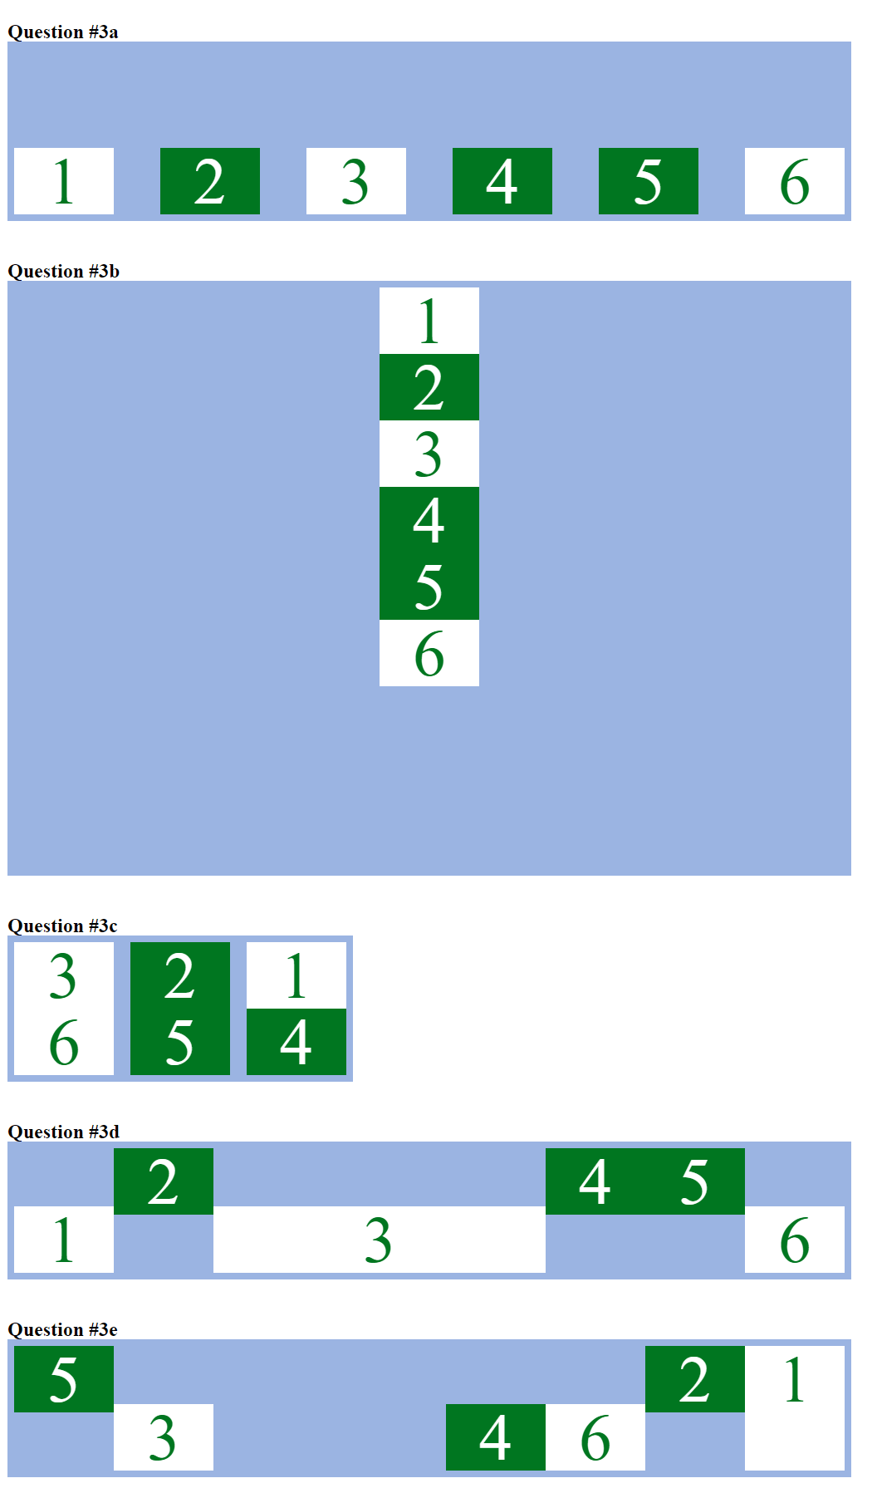

Question 4:

<https://loki.trentu.ca/~konradbartlett/3420/assignments/assn1/q4.html>

Q4.html:

<!DOCTYPE html>

<html lang="en">

<head>

<title>Choas Reigns</title>

<meta name="viewport" content="width=device-width, initial-scale=1">

<meta charset="UTF-8" />

<link ref="stylesheet" href="css/reset.css">

<link rel="stylesheet" href="css/bootstrap.css">

<link rel="stylesheet" href="css/q4.css" type="text/css" media="all" />

<link href="https://fonts.googleapis.com/css?family=Press+Start+2P" rel="stylesheet">

</head>

<body>

<div id="home">

<div class="banner_pvt">

<div class="text-center">

<nav>

<label for="drop" class="toggle">Menu</label>

<input type="checkbox" id="drop" />

<ul class="menu">

<li><a href="q4.html" class="active">Home</a></li>

<li>

<label for="drop-2" class="toggle toogle-2">Dropdown <span aria-hidden="true"></span>

</label>

<a href="#">Dropdown <span aria-hidden="true"></span></a>

<input type="checkbox" id="drop-2" />

<ul class="text-left">

<li><a href="#about">Lore</a></li>

<li><a href="#what">Abilities</a></li>

</ul>

</li>

<li><a href="gallery.html">Gallery</a></li>

</ul>

</nav>

</div>

<div class="banner-text">

<div class="banner-bot">

<h1><a href="q4.html">Death and Destruction</a></h1>

<p>I am Choas Knight and I bring an end to light</p>

<a href="gallery.html" class="btn button-style">All that is light is cast in darkness</a>

</div>

</div>

</div>

</div>

<section id="about">

<div class="container pt-xl-5 pt-lg-3">

<div class="row about-grids">

<div class="col-lg-5 about-left">

<img src="img/ab.jpg" alt="" class="img-fluid" />

</div>

<div>

<h3>Armegedon is here</h3>

<a href="gallery.html" class="btn button-style-3">LOOK AT ME</a>

</div>

<div class="about-right p-lg-0 mt-lg-0 mt-sm-5 mt-4">

<h3>Our Mission</h3>

<p class="mb-3">The veteran of countless battles on a thousand worlds, Chaos Knight hails from a far upstream plane where the fundamental laws of the universe have found sentient expression. Of all the ancient Fundamentals, he is the oldest and most tireless, endlessly searching out a being he knows only as "The Light." Long ago the Light ventured out from the progenitor realm, in defiance of the first covenant. Now Chaos Knight shifts from plane to plane, always on the hunt to extinguish the Light wherever he finds it. A thousand times he has snuffed out the source, and always he slides into another plane to continue his search anew</p>

</div>

</div>

</div>

</section>

<section id="gap">

<div class="container py-xl-5 py-lg-3">

<div class="title-bg text-center py-5 mb-5">

<h3 class="text-wh">Our champion</h3>

<p class="mx-auto">I shall not stop until the keeper of the light is elimiated</p>

</div>

<div class="row">

<div class="grids-tem-one">

<div class="row">

<div class="col-5 grids-img-left">

<img src="img/tra1.jpg" alt="" class="img-fluid">

</div>

<div class="col-7 right-cont">

<h4 class="mb-3 let tm-clr">Chaos Bolt</h4>

<p>Throws a mysterious bolt of energy at the target unit. It stuns for a random duration and deals random damage.</p>

</div>

</div>

</div>

<div class="grids-tem-one">

<div class="row">

<div class="col-5 grids-img-left">

<img src="img/tra2.jpg" alt="" class="img-fluid">

</div>

<div class="col-7 right-cont">

<h4 class="mb-3 let tm-clr">Reality Rift</h4>

<p>Teleports you, any images you have and the target unit to a point along the line between the two of you. Slows the target's movement and attack speed.</p>

</div>

</div>

</div>

</div>

<div class="row pt-lg-3">

<div class="grids-tem-one">

<div class="row">

<div class="col-5 grids-img-left">

<img src="img/tra3.jpg" alt="" class="img-fluid">

</div>

<div class="col-7 right-cont">

<h4 class="mb-3 let tm-clr">Chaos Strike</h4>

<p>Chaos Knight's attacks deal a critical strike of varying strength, in addition to a lifesteal for 40%/50%/60%/70% of the damage.</p>

</div>

</div>

</div>

<div class="grids-tem-one">

<div class="row">

<div class="col-5 grids-img-left">

<img src="img/tra4.jpg" alt="" class="img-fluid">

</div>

<div class="col-7 right-cont">

<h4 class="mb-3 let tm-clr">Phantasm</h4>

<p>Summons several phantasmal copies of the Chaos Knight from alternate dimensions. The phantasms deal 50%/75%/100% damage, but take 260% damage.</p>

</div>

</div>

</div>

</div>

</div>

</section>

<div class="serives-w3pvt-mobi bg-li py-5" id="what">

<div class="container py-xl-5 py-lg-3">

<div class="title-bg text-center py-5 mb-5">

<h3 class="tittle text-wh let mb-2 pt-sm-3">What we do ?</h3>

<p class="text-li mx-auto pb-sm-3">Murder everything in our way and consume light with shadow</p>

</div>

<div class="row welcome-bottom pt-4">

<div class="col-md-4 welcome-grid">

<h4 class="my-3">Kill stuff</h4>

<p>I am your end</p>

</div>

<div class="col-md-4 welcome-grid my-md-0 my-4">

<h4 class="my-3">Get paid</h4>

<p>It's a grind</p>

</div>

<div class="col-md-4 welcome-grid">

<h4 class="my-3">Destroy enemies</h4>

<p>Nothing will stop me from my goal, anything stopping me is my enemy</p>

</div>

</div>

<div class="row welcome-bottom mb-xl-4 mt-md-5 my-md-0 my-4">

<div class="col-md-4 welcome-grid">

<h4 class="my-3">Shift between realms</h4>

<p>Shifting between realms to hangout with my boys is the best</p>

</div>

<div class="col-md-4 welcome-grid my-md-0 my-4">

<h4 class="my-3">Roll dice</h4>

<p>If Monte Carlo taught me anything, it's that dice are chaotic</p>

</div>

<div class="col-md-4 welcome-grid">

<h4 class="my-3">Drink smoothies</h4>

<p>Elementals need to stay healthy too</p>

</div>

</div>

</div>

</div>

<section class="middle py-5 text-center" id="some">

<div class="container py-xl-5 my-lg-5">

<span class="w3-line text-uppercase mb-3">Destruction</span>

<h3 class="w3pvt-web-title mb-4">Join our legion</h3>

<p class="text-botm-mid text-wh">Upon his steed Armageddon he rides, wading into battle with maniacal frenzy, drawing strength from the disorder of the universe. A physical manifestation of chaos itself, in times of need he calls upon other versions of himself from other planes, and together these dark horsemen ride into battle, as unstoppable as any force of nature. Only when the last Light of the world is scoured from existence will the search be ended. Where rides the horsemen, death shall follow</p>

<a href="#about" class="btn button-style-2 mt-sm-5 mt-4">Read More</a>

</div>

</section>

<a href="#home" class="move-top text-center"></a>

</body>

</html>

Gallery.html:

<!DOCTYPE html>

<html lang="en">

<head>

<title>Horse Gallery</title>

<meta name="viewport" content="width=device-width, initial-scale=1">

<meta charset="UTF-8" />

<link ref="stylesheet" href="css/reset.css">

<link rel="stylesheet" href="css/bootstrap.css">

<link rel="stylesheet" href="css/q4.css" type="text/css" media="all" />

<link href="https://fonts.googleapis.com/css?family=Press+Start+2P" rel="stylesheet">

</head>

<body>

<div id="home">

<div class="banner_pvt-3">

<div class="text-center">

<h1><a href="q4.html" class="logo text-wh editContent">I am chaos reborn</a></h1>

</div>

</div>

</div>

<div id="thumbwrap">

<a class="thumb" href="#"><img src="img/g1.jpg" alt=""><span><img src="img/g1.jpg" alt=""></span></a>

<a class="thumb" href="#"><img src="img/g2.jpg" alt=""><span><img src="img/g2.jpg" alt=""></span></a>

<a class="thumb" href="#"><img src="img/g3.jpg" alt=""><span><img src="img/g3.jpg" alt=""></span></a>

<a class="thumb" href="#"><img src="img/g4.jpg" alt=""><span><img src="img/g4.jpg" alt=""></span></a>

<a class="thumb" href="#"><img src="img/g5.jpg" alt=""><span><img src="img/g5.jpg" alt=""></span></a>

<a class="thumb" href="#"><img src="img/g6.jpg" alt=""><span><img src="img/g6.jpg" alt=""></span></a>

<a class="thumb" href="#"><img src="img/g7.jpg" alt=""><span><img src="img/g7.jpg" alt=""></span></a>

<a class="thumb" href="#"><img src="img/g8.g8" alt=""><span><img src="img/g8.jpg" alt=""></span></a>

<a class="thumb" href="#"><img src="img/g9.jpg" alt=""><span><img src="img/g9.jpg" alt=""></span></a>

</div>

</body>

</html>

Q4.css:

body {

padding: 0;

margin: 0;

background: BLACK;

color: white;

font-family: 'Press Start 2P', cursive;

text-shadow: 4px 5px 12px black;

}

.toggle-2,

.toggle,

[id^=drop] {

display: none;

}

nav {

margin: 0;

padding: 0;

}

nav:after {

content: "";

display: table;

clear: both;

}

nav ul {

padding: 0;

margin: 0;

list-style: none;

position: relative;

}

h1 a {

color: white;

}

nav ul li {

margin: 0px;

display: inline-block;

}

nav a {

color: white;

font-size: 14px;

letter-spacing: 1px;

display: inline-block;

margin: 0 12px;

font-weight: 700;

text-transform: uppercase;

}

nav a:hover {

color: #717070;

opacity: .8;

}

nav ul li ul li a:hover {

color: #000;

background: #f8f9fa;

transition: 0.5s all;

}

.menu li a.active {

opacity: .8;

}

nav ul ul {

display: none;

position: absolute;

top: 25px;

background: #333;

padding: 10px;

border-radius: 4px;

left: 38%;

}

nav ul li:hover>ul {

display: inherit;

}

nav ul ul li {

width: 170px;

float: none;

display: list-item;

position: relative;

border-radius: 4px;

transition: 0.5s all;

}

nav ul ul li:nth-child(4) {

margin-bottom: 5px;

}

nav ul ul li a {

color: white;

padding: 4px 10px;

display: block;

font-size: 12px;

margin: 0;

margin-bottom: 10px;

}

nav ul ul ul li {

position: relative;

top: -60px;

left: 170px;

}

li>a:only-child:after {

content: '';

}

/* banner */

.banner_pvt {

background: url(../img/2.jpg) no-repeat center;

background-size: cover;

min-height: 850px;

position: relative;

z-index: 1;

}

.banner-text {

padding: 10em 0 1em;

}

.banner-bot {

background: rgba(0, 0, 0, 0.75);

padding: 3em 4em;

max-width: 850px;

}

.banner-bot p {

border-color: rgba(255, 255, 255, 0.39) !important;

}

a.logo {

font-size: 48px;

letter-spacing: 6px;

}

.banner-text.text-center p {

font-size: 16px;

font-weight: 100;

}

.button-style {

padding: 14px 34px;

color: white;

font-size: 14px;

text-transform: uppercase;

letter-spacing: 3px;

border-radius: 10px;

border-color: rgba(238, 238, 238, 0.23);

margin-top: 3em;

}

.title-bg {

background: url(../img/tit-bg.jpg) no-repeat center fixed;

background-size: cover;

}

h3.tittle {

font-size: 36px;

}

.title-bg p {

max-width: 700px;

font-size: 13px;

}

.grids-tem-one {

border: 1px solid #bbbaba;

padding: 20px;

}

.middle {

background: url(../img/bg1.jpg) no-repeat top;

background-size: cover;

}

.button-style-2 {

padding: 14px 24px;

border: none;

color: #332929;

font-size: 14px;

text-transform: uppercase;

letter-spacing: 1px;

background: #fff;

font-weight: 600;

border-radius: 4px;

}

a.button-style-3 {

border: 1px solid white;

color: white;

border-radius: 0px;

padding: 13px 22px;

background-color: black;

font-size: 13px;

letter-spacing: 1px;

font-weight: 600;

margin-top: 3em;

}

.banner-text-2 {

padding: 10em 0 1em;

}

.banner-bot-2 {

background: rgba(0, 0, 0, 0.75);

padding: 3em 4em;

max-width: 600px;

}

.banner_pvt-3 {

background: url(../img/b2.jpg) no-repeat center;

background-size: cover;

min-height: 600px;

position: relative;

z-index: 1;

}

#thumbwrap {

margin:75px auto;

width:252px; height:252px;

}

.thumb {

float:left;

position:relative;

margin:3px;

}

.thumb img {

border:1px solid #000;

vertical-align:bottom;

width: 100%;

height: 100%;

object-fit: contain;

}

.thumb:hover {

border:0;

z-index:1;

}

.thumb span {

position:absolute;

visibility:hidden;

}

.thumb:hover span {

visibility:visible;

top:37px; left:37px;

transform: scale(3);

}

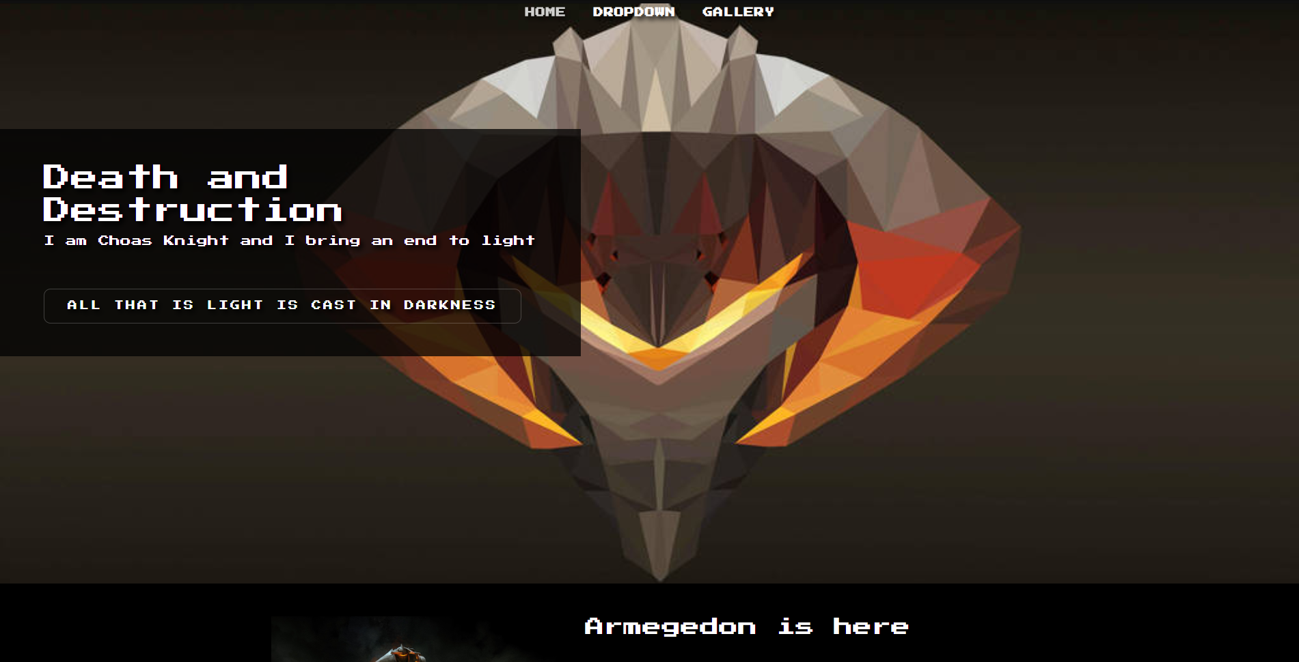

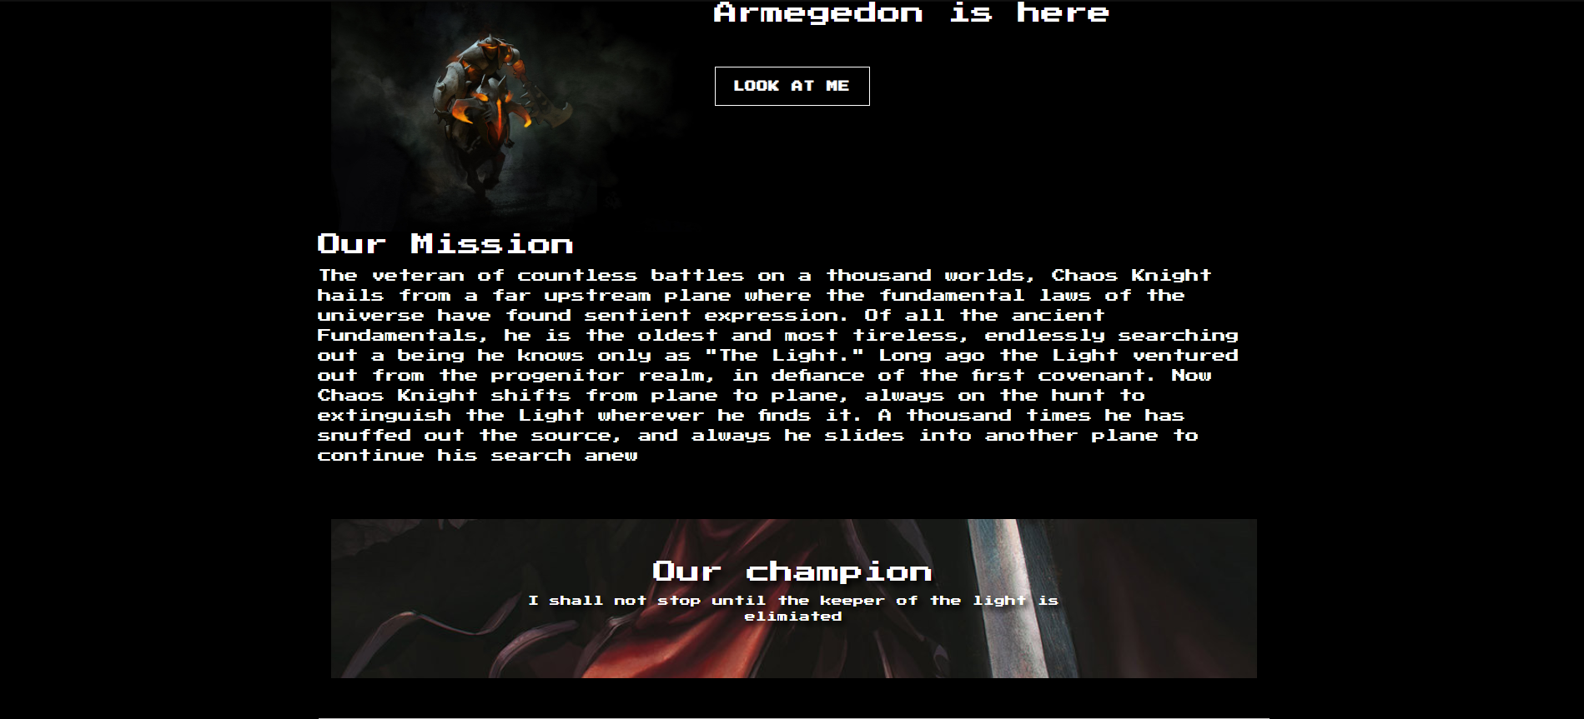

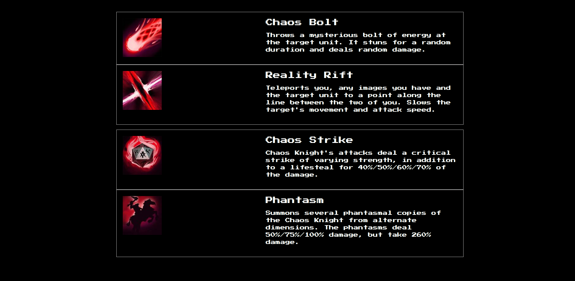

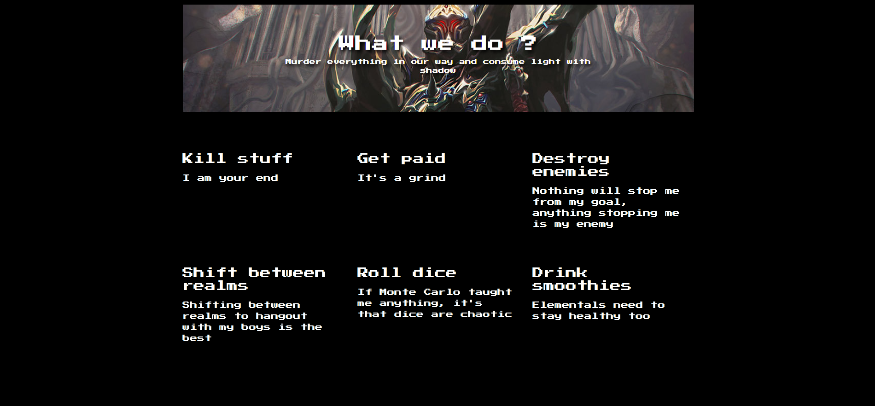

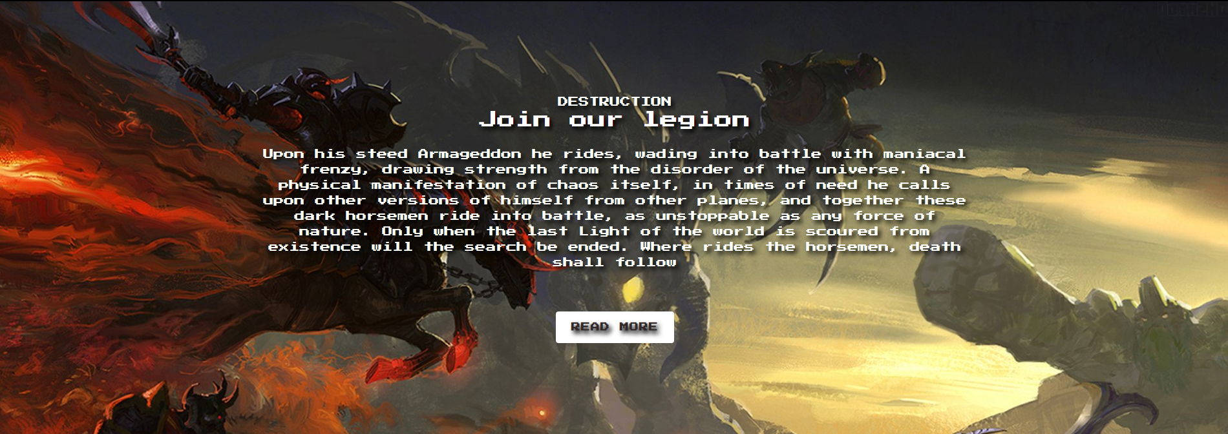

(A second page)

https://loki.trentu.ca/~konradbartlett/3420/assignments/assn1/gallery.html

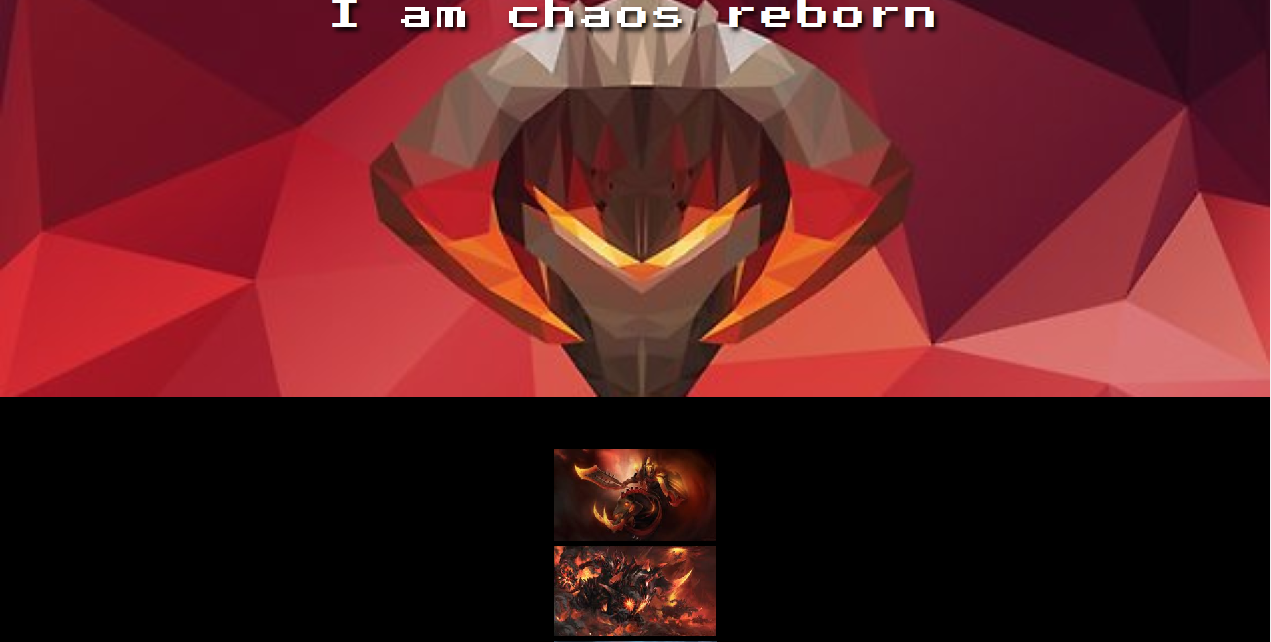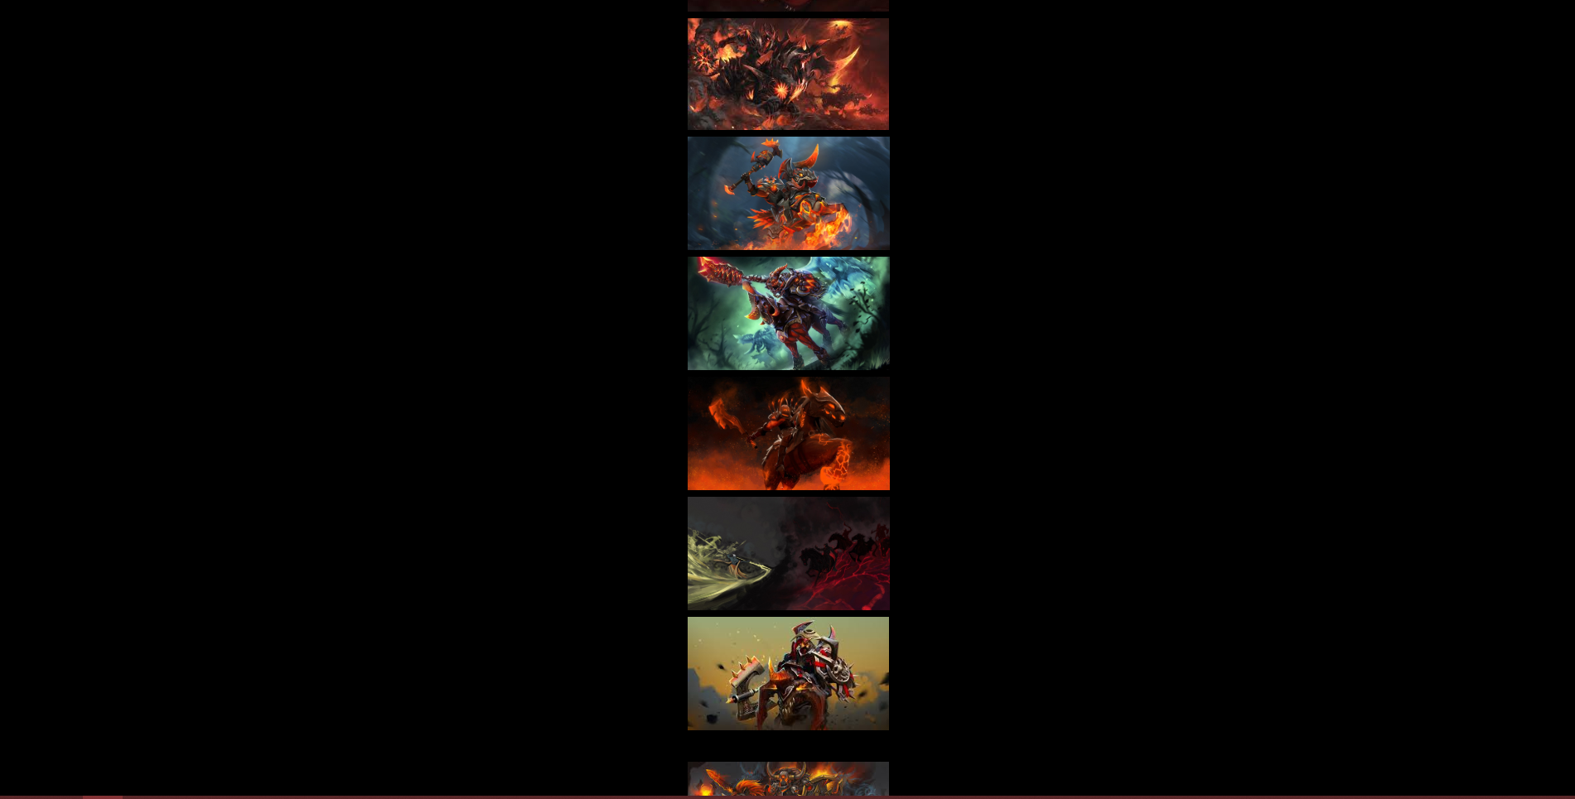

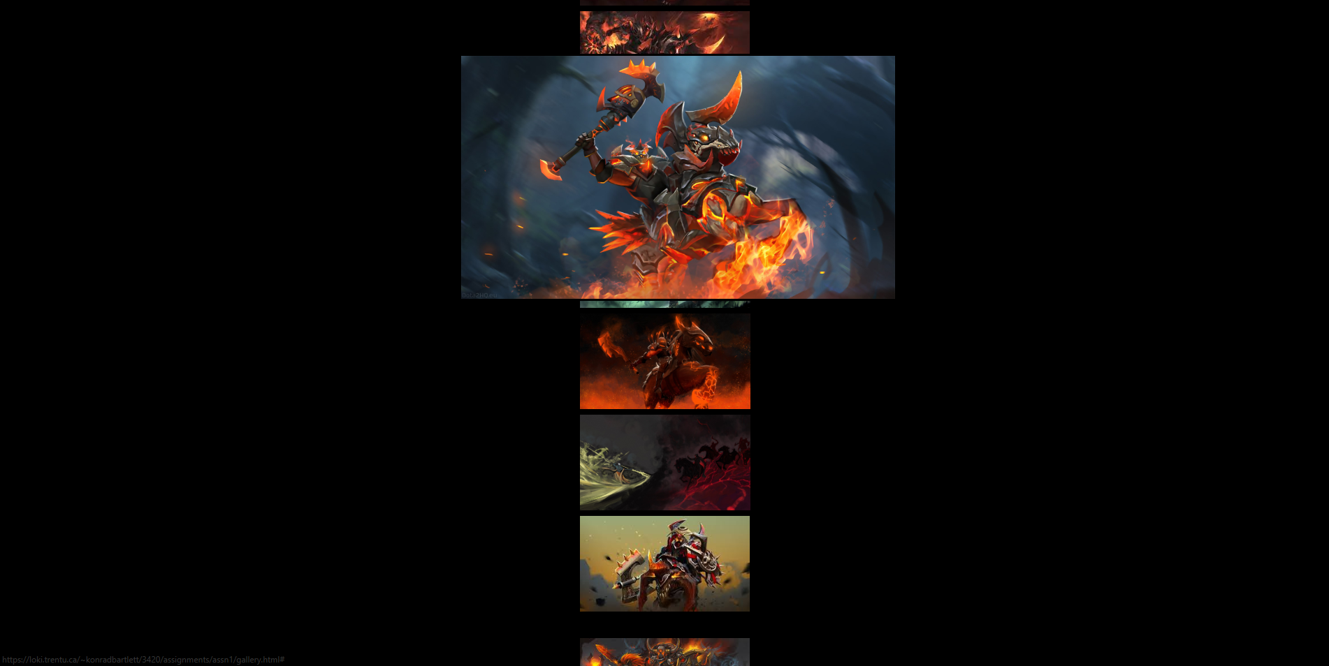

(hover)